# Menu User Manual

## Information

The menu is best described by the possible path outcomes you can follow by clicking on menu options. To run the simulation you must first setup select the profile option. This will take you to the setup screen where you can setup a profile or just use the default empty one and jump right into the simulation. It is important that you go to the configuration area and setup the sensitivity of the device you are using as well as the speeds for the various levels.

If you require any information about the devices themselves you can go to the help and about areas where a display screen of the device you are using will show up and explain any setup instructions that you require before taking part in the simulation, as well as some general information.

## Menu Navigation Diagram

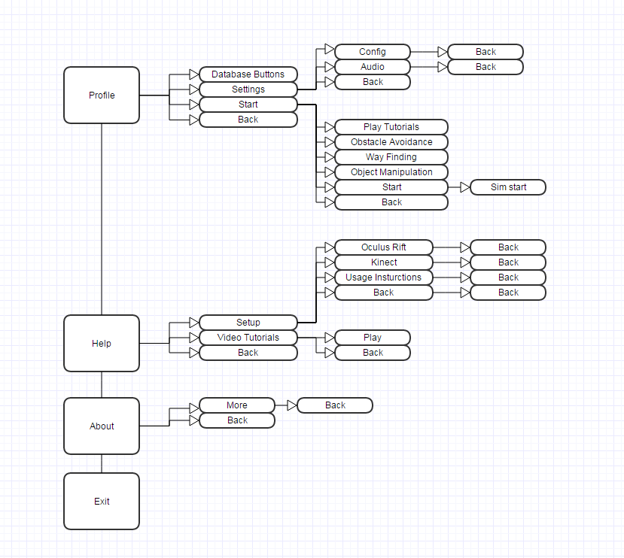

This is a menu map of how the menu functions. This shows which button leads to what for the main menu functions of our application.

## Button Functions

### Back

The back button will always return the menu to its previous selection of menu options

### Sim Start

This is not a button but it signifies the simulation starting

### Notes

This is a button map and does not show what is actually contained in those menu option locations. To see what is contained in the menu options, run the program and follow a menu path until you reach your desired destination.